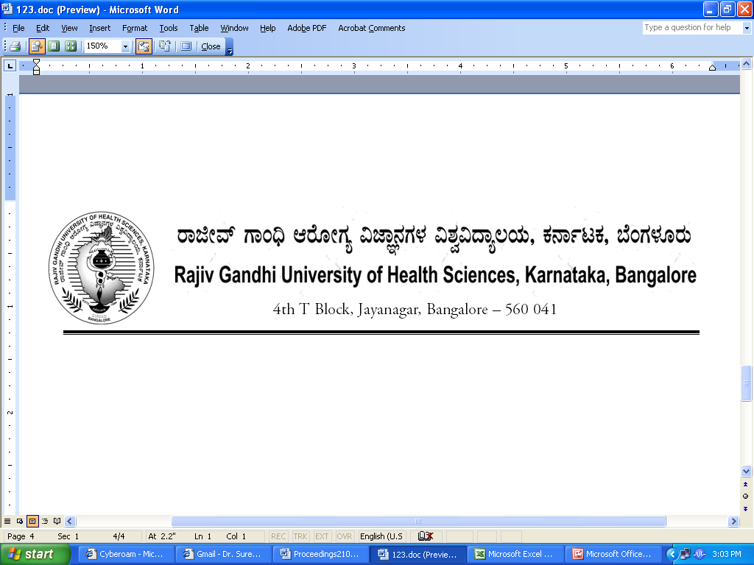
Reg (E)/Exam/Nursing/Sept - 2018 Date: 25/10/2018

CIRCULAR

Sub: | Conduct of B.Sc Nursing (Basic & PB) Course Practical Examination during October /November-2018
Ref: | Request Letter from Chairman BOS (UG) & Principals, Nursing Colleges affiliated to RGUHS.

* * * * *

With reference to the above subject, the following practical examination dates of B.Sc Nursing (Basic & PB) October /November-2018 are rescheduled as shown below
SL NO | Scheduled Dates | Extended Dates
1 | 10.10.2018 to 31.10.2018 | 10.10.2018 to 17.11.2018

Note: The Practical examinations are not to be conducted between 29.10.2018 to 01.11.2018 in view of Senate Election

The Principals are requested to notify this on the Notice Board of their colleges prominently

By Order

Sd/-
Dr. M.K.Ramesh
Registrar [Evaluation]
To:

All the Principals of the affiliated colleges for information .

Copy to:

- PA to Vice-Chancellor/Registrar/Registrar(E)/Finance Officer, RGUHS, Bangalore.
- All the Officers of the RGUHS, Bangalore.
- The Computer Department to host in our RGUHS website.
- System Analysis, RGUHS
- Guard File.

